|  |  |  |
| --- | --- | --- |
| **SR NO.** | **Table of Context** | **Page No.** |
|  |  |  |
| **1.0** | **Introduction** | **2** |
| 1.1 | Purpose. | 2 |
| 1.2 | Project Proposal. | 2 |
| 1.3 | Scope. | 3 |
|  |  |  |
| **2.0** | **Overall Description** | **4** |
| 2.1 | System Environment. | 4 |
| 2.2 | User Use Case. | 5 |
| 2.3 | Functional Requirements Specification. | 6 |
| 2.4 | Non-Functional Requirements Specification | 7 |
| 2.5 | ER Diagram. | 8 |
|  |  |  |
| **3.0** | **System design** | **9** |
| 3.1 | Description of procedures and function. | 9 |
|  |  |  |
| **4.0** | **Implementation and Testing** | **10** |
| 4.1 | Introduction. | 10 |
| 4.2 | Layouts. | 11 |
|  |  |  |

# Introduction

* **1.1 Purpose:**
* The purpose of this document is to present a detailed description of the Banking System.
* It will explain the purpose and features of the system, the interfaces of the system, what the system will do, the constraints under which it must operate and how the system will react too.

-

* **1.2** **Project Proposal:**

- Technology is one of the most important sources used in the present time and can be utilized in all areas of life, in science, education, engineering, communication, entertainment, housing and many more, Consequently, the idea was to create a service program to help people spend their needs free of charge.

* Banking System is name of the Project.
* The Project is based entirely on all users in general, as anyone who registers in the Project can open all type of account they need, and also perform all kind of Transections.
* Banking System, Also Provides you the Account Holders all transection records from account open to till date.
* Our Banking system will also provide user to have a credit card.
* **1.3 Scope:**
* Banking system is a way to maintain few records which bank holds in order to keep a track of everything in the bank so a software application is required in order to make the work easier.
* for example- maintenance of international value of INR and other currency are also a part of the job of banking system.
* The bank management is also required to act as the currency distributor and to serve the work for the nation’s well-being.
* This application is built to make it easier for the customers to track every transaction that is being made.

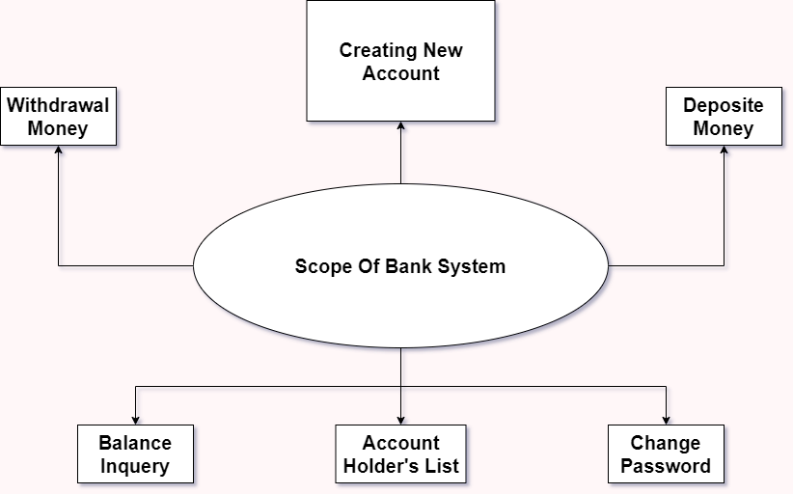

1. **Overall Description**

* **2.1 System Environment:**

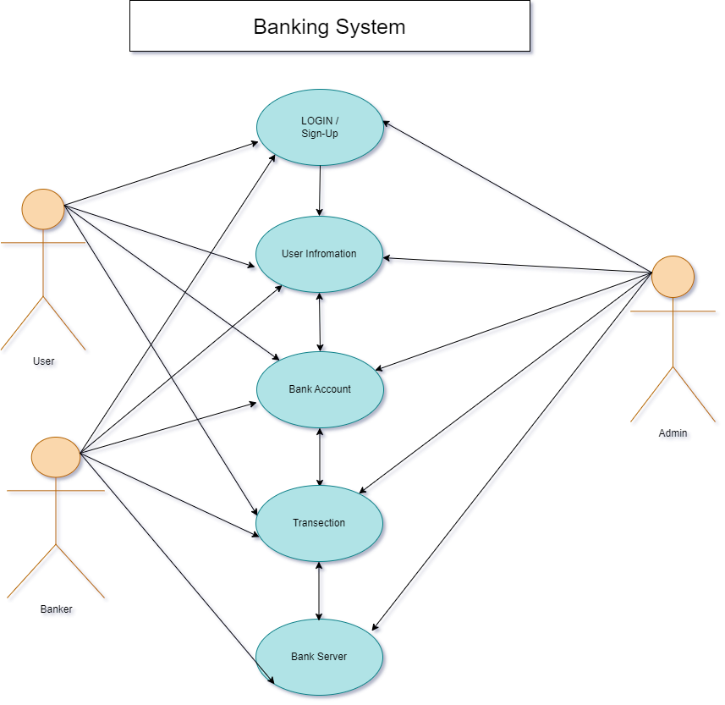

* **2.2 User Use Case:**

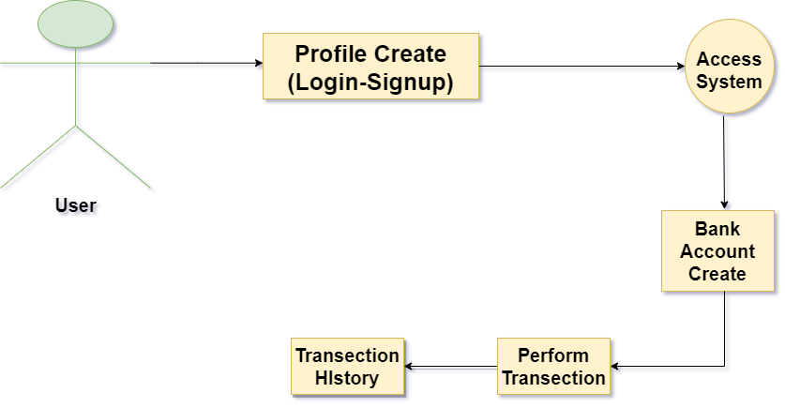

* **2.3 Functional Requirements Specification:**
* **User Authentication**:

Users can create accounts using email, password, and other relevant details.

* **Create a Bank Account:**

By Our Site User create Their Bank Account(Savings/Current) and perform Transection(Deposit/Withdrawal).

* **Credit Card:**

User can also have facility for credit card.

* **Administrator Tools & Bank Server:**

Admin and Bank both have an Authority to see users account related data.

* **2.4 Non Functional Requirements Specification:**
* **Performance:**

The banking system should work stably with good connection and handle multiple user at a time.

* **Security:**

Banking system should have secure environment to do any transection.

As well as system should have secure data of users.

* 2.5 ER Diagram:

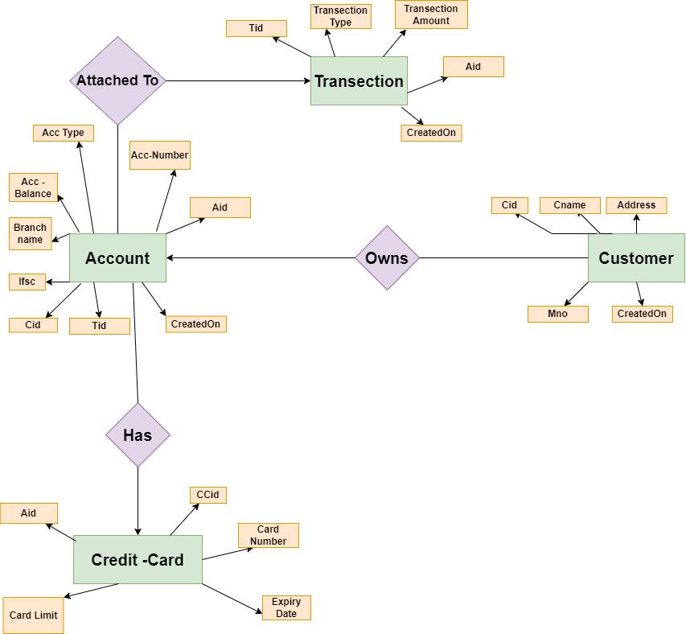

**3.0 System design**

* **3.1 Description of procedures and function**:
* The application was implemented in **.net**(**MVC)**.
* Now works on all devices.
* The application is required to have Internet to perform Transection.

1. **Implementation and Testing**

* **4.1 Introduction:**

**-** The application was implemented in **.net(MVC) Framework**.

- The databases were **SSMS**.

- The Frontend Language **Angular, HTML & CSS**.

- Contains three basic interfaces:

1. Register a new account.

2. Log in.

3. The main page.

* **4.2 Layouts:**